Proposal for Zionist church (NPO)

Ngwenya Lisa Sibongile
ST10519253
WEDE5020
Group 3
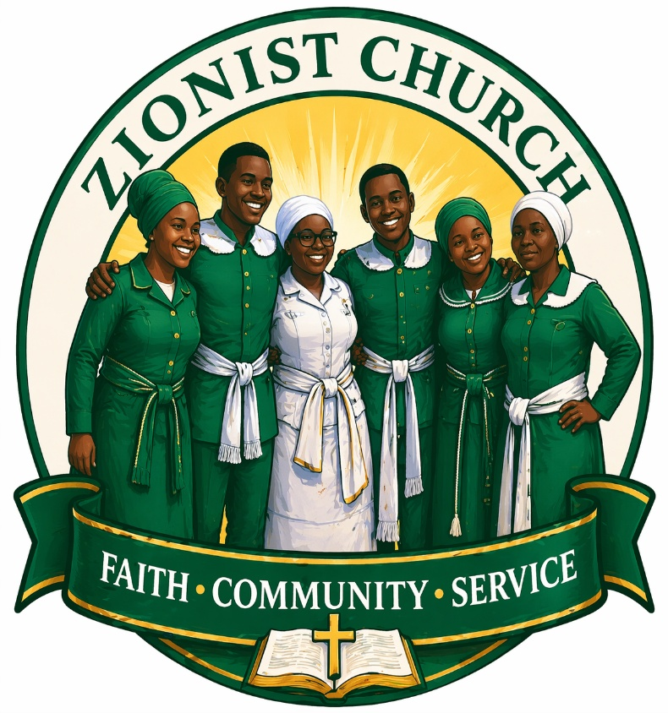
Contents
Organisation Overview 2
Zionist Churches – Brief summary 2
Mission and Vision 2
Target audience 3
Website Goals and Objectives 3
Proposed website features and functionality 3
Design and User Experience 4
Colour scheme 4
Typography 4
Technical Requirements 4
Timeline and Milestones 4
Budget 5
Content Research and sourcing 5
Website Structure and Planning 5
Sitemap 5
Page structure - contents 6
1. Homepage 6
2. About us 6
3. Directory 7
4. Photo gallery 8
5. Devotions 8
6. Contact Us 8
References 9

Organisation Overview

Zionist Churches – Brief summary
Logo:
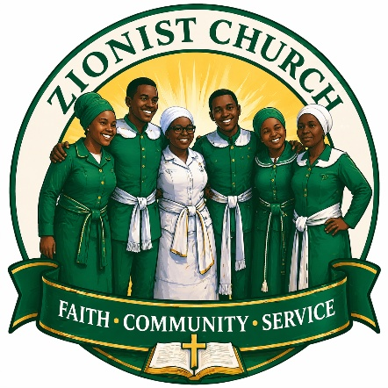
Zionist churches were established in 1904 by missionaries from Chicago, the African members then incorporated African spirituality which was defined as the second baptism of the spirit. Zionist churches are mostly found in southern Africa, they have a rich rooted history in the Christian catholic apostolic church, the churches would incorporate the words Apostolic, Pentecostal or Faith to represent their biblical charter for example Gospel church in Zion. The Zion churches have different branches of churches such as the Zion Christian church known as the ZCC of Limpopo, AmaNazaretha formally known as the Shembe church or iBandla lamaNazaretha and AmaSiyoni or AmaKrestu of KwaZulu Natal, Methodist and so much more. The zion churches have these 2 key characteristics being Faith healing and prophecy – Zionist believe in the power of healing through the holy spirit and prophecy and Community and identity – Zionist churches believe in providing a sense of community for black south Africans that help preserve African spirituality while incorporating Christianity. (Britannica, 2012)

Mission and Vision
The vision and mission of the Zionist churches is to create a spirit filled community of believers rooted in African spirituality and Christianity. Claiming the kingdom of God through worship and prayer with dignity and giving the identity to the African people by nurturing communities through the healing, worship, prophecy, prayer and culture. (New religious movements, 2024)

Target audience
This website would be for existing Zionist church members cross different branches who are looking to explore and look for near Zionist churches, young adults or the youth within the churches, individuals who want to explore and gain knowledge on the different types of Zionist churches, scholars that are studying religion studies either in secondary school or tertiary and reporters or media professionals. Giving insight on what the Zionist churches stand for and the positive things they do for communities throughout southern Africa.

Website Goals and Objectives
The goal of this website is to provide current Zionist church members with information on nearby similar or different branches and provide information on Zionist churches to create a positive image of the churches. The key performance indicators for this website are:
- Monthly website visitors
- Time spent on the website
- Returning Website visitors
- Newsletter subscribers
- Social media followers gained
- Social media shares

Current Website Analysis
Based of my research there are quite a few websites of zion churches but they only have ones that represent a certain group such as the Shembe church has the Shembe.net website that solely focuses on the Shembe church. The ZCC and Zion churches that are apostolic or Pentecostal do not have much representation. The strengths I have noticed are a strong visual presence where they are enough images that represent the church, the weakness of the website is that it does not have other similar churches just the ones related to the one church.

Proposed website features and functionality
- Home page – it will be the first page visitors will see and it will be the gateway for all the other pages. The top left corner will have the logo and there will be a banner with the navigation linking to the other pages.
- About us page – It will explain the background of the organisation, educate on the history and beliefs of the organisation.
- Directory – It will have the list of Zionist churches in southern Africa that help people find the different churches in categories
- Photo gallery – Here there will be a gallery of the different churches
- Devotions – Here there will be the devotions of the week and prayers
- Contact us – Visitors will be able to contact the organisational branches

Design and User Experience

Colour scheme
Zionist churches have different colour schemes depending on the branch most popular colours are green, blue and white. I will be using differen shades of green and white.

- #2e9279
- #0f6e56ca
- #9FE1CB
- #106554
- #1D9E75
- white

Typography
The Times new roman font will be used while using different heading styles to create a hierarchy of the different headings.
Home page
About us page
Directory
Newsletter
Photo gallery
Devotions
Contact us

Technical Requirements
The technical requirements to build the websites are the markup language being HTML and the programming languages CSS and JavaScript through visual studio code. Microsoft edge and/or Chrome web browser will be used to view the webpages.

Timeline and Milestones
Week 1 – Research and Planning
Week 2 – Choosing a domain and host
Week 3 – Design and layout of websites
Week 4 – Building webpages and adding photos for photo gallery
Week 5 – Testing and launch

Budget
The budget is broken down like this:
- The domain cost will be about R250 per month. The web address to be used will be .org as it will be more affordable.
- The web hosting cost will be about R200 per month.
- The web development will be done by myself therefore it would be free.

Content Research and sourcing
The content that is going to be on the website is images, videos and information related to the organisation. Most websites from my research offer shared testimonials so there will be a section dedicated to sharing testimonials and stories from the congregation which can build trust and inspire new visitors. This includes member testimonials, success stories from ministries, and video testimonials for a more personal touch. (The Church Co,2024)

Website Structure and Planning

Sitemap

Page structure - contents

Homepage
Welcome message, brief message and navigation board

About us
History of the organisation, Vision and mission statement and the different branches.
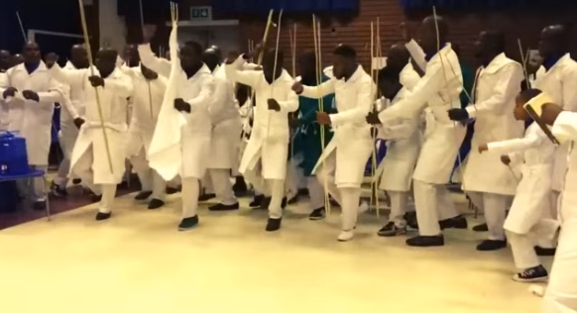
Figure 1 Apostolic Zion
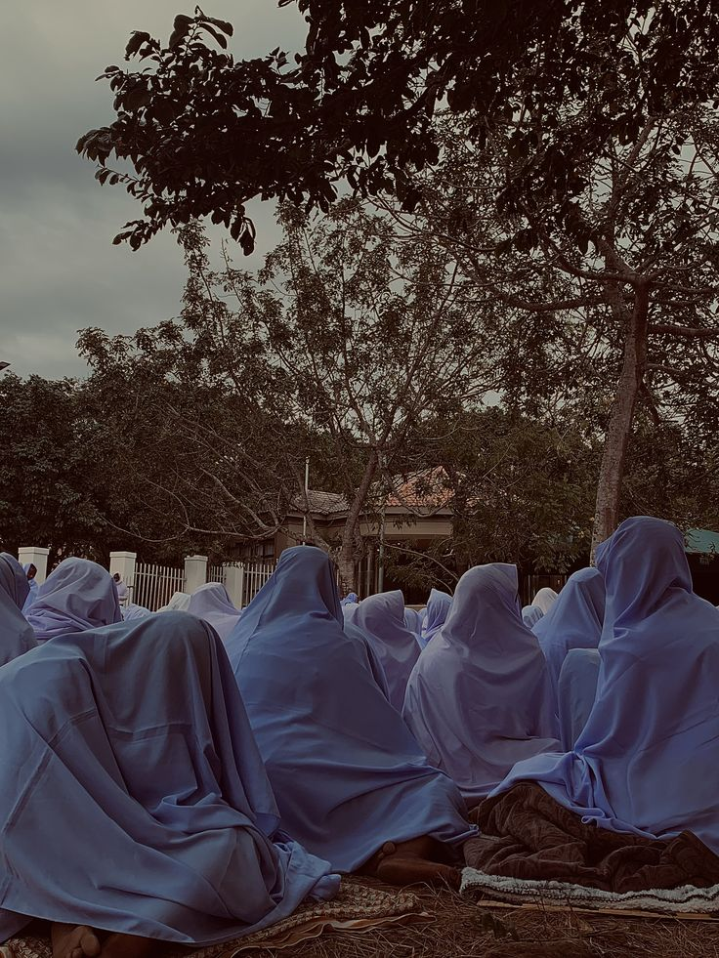
Figure 2 Ebuhleni Shambe Church

Figure 3 ZCC choir

Directory
List of the different churches in categories with locations of the churches with images representing the type of church:
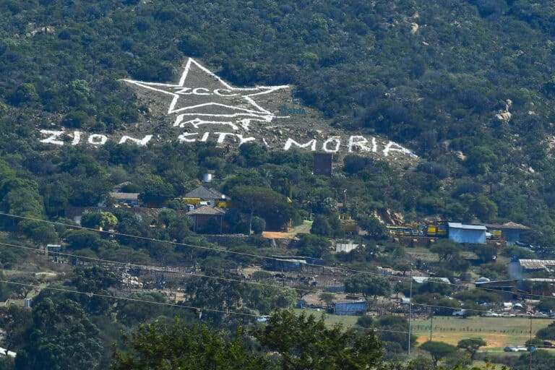
Figure 4 ZCC headquarters
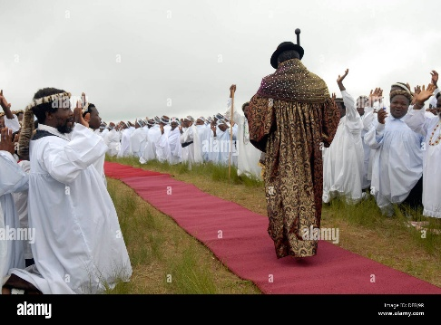
Figure 5 Shembe church with leader
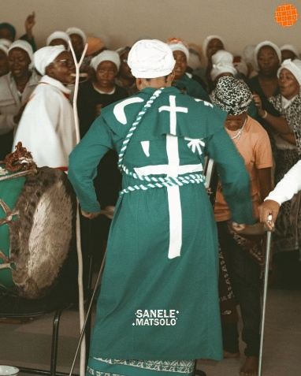
Figure 6 Zion church
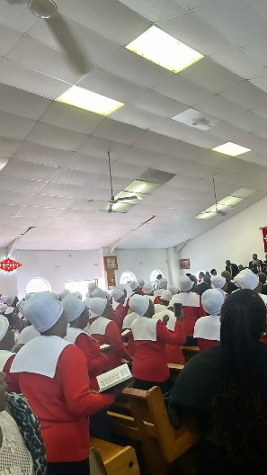
Figure 7 Methodist Church

Photo gallery
The photo gallery will have 6 different images of each church and its activities.

Devotions
Devotions for the week and prayers

Contact Us
Contact information such as an email address, contact number and address

References
Britannica, 2012. Zionist church. [online] available at www.britannica.com/topic/Zionist-church [Accessed 7 April 2026]. Zionist church | South African Religion & History | Britannica
New religious movements, 2025 Zionist churches. [online] available at https://newreligiousmovements.org/v-z/Zionist-churches/ [Accessed 7 April 2026] Zionist Churches
Logo, 2026. ( the image was generated by chatgpt)
Christina Langa. Apostolic (Zion) Mix. [online] available at https://za.pinterest.com/pin/665547651194096972/
Thandeka_mafuze. Church/Ebuhleni. [online] available at https://za.pinterest.com/pin/1084523154025063673/
M3ga Arts. Brought together by prayer and worship. [online] available at https://za.pinterest.com/pin/744642119677141228/
SaneleMatsolo. Sethembe yena usomandla SANELE MATSOLO. [online] available at https://za.pinterest.com/pin/31666003624465257/
Alamy, 2019. Shembe hi-res stock photography and images – Alamy. [online] available at shembe - Search Images
Wavela Nteleza. [online] available at https://za.pinterest.com/pin/702702348154611783/
The Citizen, 2024. Travellers warned of heavy traffic as ZCC resumes Moria conferences. [online] available at www.citizen.co.za/news/heavy-traffic-zcc-resumes-moria-conference/
The Gazzete Botswana, 2021. ZCC to remain closed. [online] available at www.thegazette.news/news/zcc-to-remain-closed/
The Church Co, 2024. 12 Things Every Church Website Must Have. [online] available at https://thechurchco.com/blog/2024/05/28/12-things-every-church-website-must-have/

